**Section 2–1A: Relations and Functions**

A **relation** is a set of pairs of input and output values. You can represent a relation in four different ways as shown below.

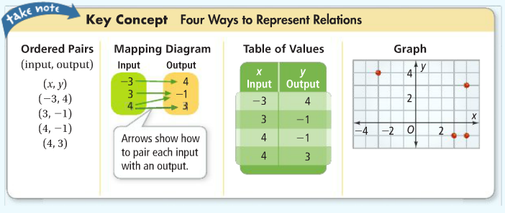

**Example 1: Representing a Relation**

The monthly average water temperature of the Gulf of Mexico in Key West, Florida varies during the year. In January, the average water temperature in 69oF, in February, 70oF, in March, 75oF, and in April, 78oF. How can you represent this relation in four different ways?

**Mapping Diagram Ordered Pairs**

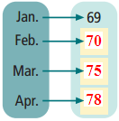

**Table of Values Graph**

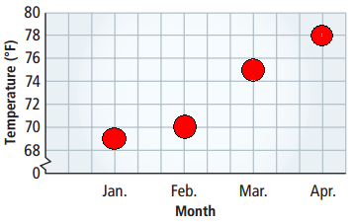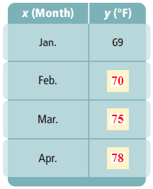

The **domain** of a relation is the set of inputs, also called *x*-coordinates, of the ordered pairs. The **range** is the set of outputs, also called *y*-coordinates, of the ordered pairs.

**Example 2: Finding Domain and Range**

What are the domain and range of this relation? {(–3, 14), (0, 7), (2, 0), (9, –18), (23, –99)}

The domain is the set of *x*-coordinates: **{–3, 0, 2, 9, 23}**

The domain is the set of *y*-coordinates: **{14, 7, 0, –18, –99}**

A **function** is a relation in which each element of the domain corresponds with exactly one element of the range.

**Example 3: Identifying Functions**

Is the relation a function?

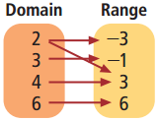**a)** **b)** {(–7, 14), (9, –7), (14, 7), (7, 14)}

1. Each *x*-coordinate must correspond to only one *y*-coordinate. The *x*-coordinate 2 corresponds to –3 and 3. The relation **is not** a function.
2. Each element in the domain corresponds with exactly one element in the range. This relation **is** a function.

You can use the **vertical –line test (VLT)** to determine whether a relation is a function. The VLT states that if a vertical line passes through more than one point on the graph of a relation, then the relation is **not** a function.

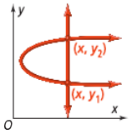**Why it works?**

If a vertical line passes through a graph at more than one point, there is more than one value in the range that corresponds to one value in the domain.